Parth Babbar

investment banking operation

**Introduction:**

Investment banks are financial firms that specialise in big and sophisticated transactions, such as underwriting new debt and equity instruments, arranging mergers and acquisitions, and offering investment advice services. They play an important role in the financial system by assisting firms in obtaining money, facilitating securities transactions, and providing strategic financial advice to organisations and people. These services improve the efficiency and stability of the financial markets.

**Core Operations:**

1. **Underwriting:** Investment banks help corporations and governments raise funds through Initial Public Offerings (IPOs) and debt issuance. IPOs allow firms to go public by underwriting and distributing shares. They underwrite corporate bonds and other financial products. Underwriting is the process of acquiring the complete issue of securities from the issuer and selling them to investors. In 2023, US investment banks underwrote $1.5 trillion in debt and equity transactions.
2. **Mergers & Acquisitions:** Investment banks play an important role in enabling complicated financial transactions, including mergers, acquisitions, and corporate restructurings. They provide critical advice services like as appraisal, negotiation, and due diligence. Investment banks thrive in executing these deals, ensuring that customers' goals are met. The US M&A market was strong in 2023, with over 12,000 deals worth at $2.4 trillion, emphasising the critical role that investment banks play in influencing company strategy and market dynamics.
3. **Sales & Trading:** Investment banks act as financial market middlemen, generating liquidity by buying and selling securities. They also engage in proprietary trading, which involves trading financial products such as stocks, bonds, derivatives, and commodities using their own cash. Furthermore, investment banks provide brokerage services, executing deals on behalf of their clients. In 2023, US investment banks made roughly $120 billion in trading income, highlighting their importance in financial markets and capacity to manage and benefit from market swings.
4. **Asset Management:** Investment banks play an important role in asset management by supervising investments for customers through portfolio management and consulting services. They manage a wide range of investment vehicles, including mutual funds and hedge funds, to serve to different investment strategies and risk profiles. Additionally, investment banks provide wealth management services, including personalised investment advice and thorough portfolio management. In 2023, US investment banks jointly handled assets worth $25 trillion, demonstrating their tremendous influence in the global financial ecosystem and capacity to manage significant wealth for customers.
5. **Research:** Investment banks do substantial research, including equity research, which examines firms and industries to make investment recommendations, and economic research, which provides macroeconomic analysis and projections. This study helps investors make informed decisions by providing useful insights into financial markets and economic developments. US investment banks jointly contribute around $5 billion per year to these research activities, demonstrating their commitment to delivering informed opinions that impact investment strategies and market results.

**Regulatory Environment:**

Investment banks are subject to laws aimed at preserving market integrity and protecting investors. The key regulatory bodies include:

1. **Securities and Exchange Commission (SEC)**
2. **Financial Industry Regulatory Authority (FINRA)**
3. **Commodity Futures Trading Commission (CFTC)**

**Key Players:**

1. **Goldman Sachs**
2. **Morgan Stanley**
3. **JPMorgan Chase (Investment Banking Division)**
4. **Bank of America Merrill Lynch**
5. **Citigroup (Citi Investment Banking)**A screenshot of a phone

   Description automatically generated

**Latest Trends & Developments:**

1. **Tech-Driven Innovation:** The use of artificial intelligence and big data analytics to trading and advising services.
2. **Sustainable Finance:** A greater emphasis on green bonds and sustainable   
   investment products.
3. **Regulatory Compliance:** Increased compliance procedures in response to stringent regulatory obligations.
4. **Global Expansion:** Expanding operations into developing areas to capitalise on growth prospects.

**Statistics:**

1. **Total Revenue**: Approximately $140 billion annually.
2. **Number of Employees**: Around 390,975 professionals.

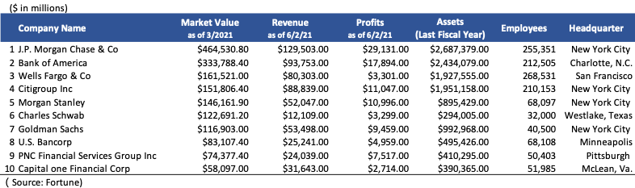

**Conclusion:**

Investment banks play an important role in the financial system since they provide a variety of services that aid in capital formation, business restructuring, and market activities. Despite several hurdles, they continue to evolve by harnessing technology and adjusting to regulatory changes, assuring their ongoing relevance and contribution to the economy.